**Implementing Mobile Based Interface for eLearning**

**A Case Study of SODeL**

**James Njoroge Njuguna**

**SCT221-6809/2015**

**A Research Project submitted to the Department of Information Technology in the School of Computing and Information Technology in partial fulfillment of the requirement for the award of Degree in Information Technology in Jomo Kenyatta University of Agriculture and Technology.**

**2019**

# **Declaration**

**Declaration by Student**

I JAMES NJOROGE NJUGUNA hereby declare that this research project is my original work and has not been presented in another university or institution for consideration for any academic certification.

Sign ……………… Date………………………

James Njoroge Njuguna

**Declaration by Supervisor**

This is to certify that the research project has been submitted for examination with my approval as University supervisor

Sign ……………… Date………………………

Nancy Macharia

Project Supervisor

# 

# **Dedication**

I dedicate this research to my inspiring parents for their efforts, sacrifices, mentorship, and guidance through this course.

I also dedicate this project to God Almighty my creator, my strong pillar, my source of inspiration, wisdom, knowledge and understanding. He has been the source of my strength throughout this research.

# 

# 

# **Acknowledgement**

First, I therefore take this opportunity to express my sincere gratitude to the Almighty God for this far He has brought me and for providing me with the opportunity to carry out these research activities.

I also like to acknowledge the work of my supervisor, for guidance and support in coming up with the correct research format.

I would also like to thank my parents for their moral and financial support throughout the research period.

**Table of Contents**

**Research Area** i

**Declaration** ii

**Dedication** iii

**Acknowledgement** iv

**Abbreviations and Acronyms** 1

**Definition of Terms** 2

**Chapter 1.** 3

**1.0 Introduction** 3

**1.1** **Problem Statement** 3

**1.2** **Proposed Solution** 3

**1.3** **Objectives** 3

**1.4 Research Questions** 4

**1.5 Justification** 4

**1.6 Scope** 4

**1.7 Methodology** 4

**1.7.1 The unified Process** 4

**1.7.2 Phases of Design Cycles** 5

**1.7.3 Data Collection Tools** 5

**Chapter 2** 6

**Literature Review** 6

**2.1 Introduction** 6

**2.2 Interface design** 6

**2.2.1 Approaches to Designing Mobile Based Interfaces.** 7

**2.2.2 Mobile Based Interface for E-learning** 8

**2.2.3 Requirement for Designing Mobile Based Interface for eLearning** 8

**2.2.4 Methods for Implementing Mobile Based Interface for eLearning** 9

**2.2.5 Methods for Evaluation** 10

**CHAPTER 3** 12

**SYSTEM ANALYSIS AND DESIGN** 12

**3.1 Introduction** 12

**3.2 Feasibility Study** 12

**3.2.1 Behavioral Feasibility** 12

**3.2.2 Legal Feasibility** 12

**3.2.3 Operational Feasibility** 13

**3.2.4 Economic Feasibility** 13

**3.2.5 Schedule Feasibility** 13

**3.3 Requirement Elicitation** 13

**3.4 Data Analysis** 14

**3.4.1 Questionnaires Reports** 14

**3.5 System Development Methodology** 15

**3.5.1 The Unified Process** 15

**3.6 System specification** 15

**3.7 System Design** 16

**3.7.1. Logical Design** 16

**3.7.2. Physical Design** 18

**1.8 Appendices** 20

**1.8.1 Resource Requirement** 20

**1.8.1.1 Hardware** 20

**1.8.1.2 Software** 20

**1.8.1.3 Other Requirement** 20

**1.8.2 Budget and Budget Justification** 21

**1.8.3 Project Time Plan** 22

**Gantt chart** 23

**REFERENCES** 24

**List of Figures**

Figure 1 Usability Dimensions Context 8

Figure 2 Questionnaire Report 14

Figure 3 Dataflow Diagram 16

Figure 4 Use case Diagram 17

Figure 5 Sequence Diagram 18

Figure 6 Physical design 1 20

Figure 7 Physical Design 2 21

# **Abbreviations and Acronyms**

1. CEP – Continuing Educational Programme
2. GQM - Goal Question Metric
3. HCI- Human Computer Interaction
4. ICT- Information Communication Technology
5. JKUAT – Jomo Kenyatta University of Agriculture and Technology
6. LMS – Learning Management System
7. OMG- Object Management Group
8. PACMAD - People at the Centre of Mobile Application Development
9. SODeL – school of open, distance and e learning
10. SPEM- Software Process Engineering Meta-Model Specification
11. UCD - User Centered Design
12. UI - user interface
13. UML- Unified Modelling Language

# 

# **Definition of Terms**

1. Usability- The official ISO 9241-11 definition of usability is: “the extent to which a product can be used by specified users to achieve specified goals with effectiveness, efficiency and satisfaction in a specified context of use.”
2. Responsive Web Design – responds to the needs of a user and the devices they are using. The layout changes on the size and capabilities of the device. (“Ethan”, 2010 ).

# **CHAPTER 1**

## **1.0 Introduction**

Jomo Kenyatta University of Agriculture and Technology is a Higher Educational Institution located 35 kilometers North East of Nairobi along the Thika highway in Juja.

The university has several colleges and schools each offering different programs to students. One of the schools is the School of Open, Distance and eLearning (SODeL).

The School of Open, Distance and eLearning (SODeL) previously known as Continuing Educational Programme (CEP) was inaugurated in 2012 following the amalgamation of the CEP and eLearning sections thus enhancing the quality delivery of programmes. The enhanced mandate incorporates Jomo Kenyatta University of Agriculture and Technology (JKUAT) continuing education, Distance learning, Open learning and eLearning modes of study which allows a student to attain internationally Jomo Kenyatta University of Agriculture and Technology academic qualifications at own convenience.

## **Problem Statement**

A high number of students’ own use smart phone compared to those owning laptop and desktops

In SODeL the learning materials are accessed only from a web based eLearning system using a web browser the content is not automatically adjusted to accommodate the student device and context.

Mobile learners have difficulties in accessing course content on the web interface therefore the learners have to adjust the layout for a friendlier viewing as the content appears in tiny fonts that are not user friendly this reduces students’ motivation. Jung (2017) observed that learner motivation is fundamental to the learners’ success in an online coursework environment.

## **Proposed Solution**

Implement mobile interfaces for eLearning by developing a mobile application with improved interface for the learning processes

## **Objectives**

1. Examine approaches for designing interfaces for mobile devices.
2. Establish necessary usability dimensions for mobile application
3. Establish methods of evaluating the mobile interface for eLearning.
4. Implement a mobile application for eLearning.

## **1.4 Research Questions**

1. What are the approaches for designing interfaces for mobile devices?
2. What are the necessary usability dimensions for mobile applications?
3. What are the methods of evaluating interfaces?
4. How will the implementation be carried out?

## **1.5 Justification**

Improving the interface of the eLearning system will bring several benefits among them

1. The eLearning enhances training and learning in that student can access materials and contents on the eLearning platform as from the mobile devices from anywhere as long as there is an internet connection thus improving learning activities.
2. It will be more convenient education alternative for other people who wish to improve their education

## **1.6 Scope**

This research project will cover the implementation of a mobile-based interface for e-learning in Jomo Kenyatta University of Agriculture and Technology

## **1.7 Methodology**

Research methodology states how the proposed project is intended to be carried out and focuses on data collection tools, samples and sampling techniques, research design and data analysis technique.

### **1.7.1 The unified Process**

An iterative and incremental, architecture centric and use-case driven approach in developing software.

It has the following key features:

1. It is component based, commonly being used to coordinate object oriented programming projects.
2. It uses UML a diagrammatic notation for object oriented design.
3. The design process is anchored, and driven by use cases which help keep sight of the anticipated behaviors of the system.
4. It is architecture centric and its design is iterative and incremental via a prescribed sequence of design phases within a cyclic process.

### **1.7.2** **Phases of Design Cycles**

Design in the unified Process proceeds through a series of cycles, each of which has the following phases:

#### **1.7.2.1 Inception**

Produces a commitment to go ahead and by the end of this phase a business case should have been made, feasibility of the project assessed, and the scope of the design should be known.

#### **1.7.2.2 Elaboration**

Leads to a working specification of the system and the end of this phase a basic architecture should have been produced a plan of construction agreed, all significant risks identified, and those risks considered to be major should have been addressed.

#### **1.7.2.3 Construction**

Produces beta-release system and the end of this phase a working system should be available, sufficient for preliminary testing under realistic conditions.

#### **1.7.2.4 Transition**

Introduces the system to its intended users.

### **1.7.3 Data Collection Tools**

1. Questionnaires

Prepare a list of questions about how students interact with the eLearning system

1. Observation

Observing how contents is displayed on the eLearning system layout

# 

# **CHAPTER 2**

# **LITERATURE REVIEW**

## **2.1 Introduction**

E-learning technology is one of the most effective assets for growing knowledge, skills and development in any institution of learning. The e-learning technologies are driven by the use of Information and Communication Technology (ICT). ICT refers to the totality of methods and tools that are used in gathering, storing, processing and communicating information (Olutola & Olatoye 2015).

**Mobile based interface**

A mobile user interface is the graphical and usually touch-sensitive display on a mobile device, such as a [smartphone](https://searchmobilecomputing.techtarget.com/definition/smartphone) or [tablet](https://searchmobilecomputing.techtarget.com/definition/tablet-PC) that allows the user to interact with the device’s [apps](https://whatis.techtarget.com/definition/mobile-app), features, content and functions.

Rouse Margaret. (2019) observed that mobile user interface ([UI](https://searchwindevelopment.techtarget.com/definition/GUI)) design requirements are significantly different from those for desktop computers. The smaller screen size and [touch screen](https://whatis.techtarget.com/definition/touch-screen) controls create special considerations in UI design to ensure usability, readability and consistency. In a mobile interface, symbols can be used more extensively and controls may be automatically hidden until accessed. The symbols themselves must also be smaller and there is not enough room for text labels on everything, which can cause confusion.

Users have to be able to understand a command [icon](https://whatis.techtarget.com/definition/icon) and its meaning whether through legible text or comprehensible graphical representation. Basic guidelines for mobile interface design are consistent across modern mobile operating systems.

Other types of interface include web-based interface. Web based interface is the interaction between a user and software running on a Web server. The user interface is the Web browser and the Web page it downloaded and rendered.

## **2.2 Interface design**

User interface (UI) design is the process of making interfaces in software or computerized devices with a focus on looks or style. Designers aim to create designs users will find easy to use and pleasurable. UI design typically refers to graphical user interfaces but also includes others, such as voice-controlled ones.

### **2.2.1 Approaches to Designing Mobile Based Interfaces.**

**Mobile task**

A task can be visualized as a use case scenario based on product operation or application task. Studies by Biel et al. (2010) categorized task as functionality, workflow, interactions, duration, type, complexity and dependency.

Studies by (Raita et al., 2011) states that task difficulty can be measured in terms of product expectations.

**Mobile technology**

Device characteristics and features, hardware, software and network connectivity can categorize device profile (Biel et al., 2010). As this study concerns mobile devices, it covers the characteristics pertaining to mobile technology. According to Heo et al. (2009), they defined mobile devices as portable, self-contained information to the communication system.

According to studies by Ali et al., (2012) there are three main features of mobility: they use user’s hands, operated without cables, support applications and connected through the Internet.

**Mobile environment**

The environment can be viewed as geographic location, environmental data such as temperature, noise, social conditions such as a group of users or event that take place. It also covers the stability of connections and the capabilities of device to collaborate with others (Biel et al., 2010).

The figure below shows context

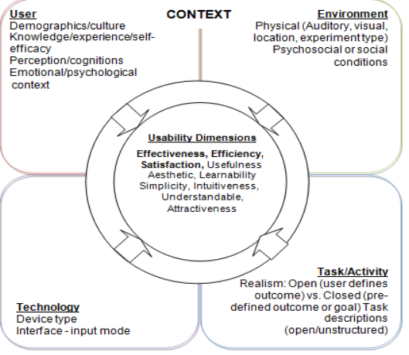

Figure 1 Usability Dimensions Context

### **2.2.2 Mobile Based Interface for E-learning**

E-learning involves learning through the use of Information and Communication Technology (ICT) infrastructures.

Rosenberg (2001) defines learning as “the process by which people acquire new skills or knowledge for the purpose of enhancing their performance”.

Studies by Georgieva et al., (2004) found that mobile-based interface is a natural extension of E-learning and has the potential to make learning even more widely available and accessible to the smart phone users. It offers open doors for the advancement of cooperation among lecturers and students.

### **2.2.3 Requirement for Designing Mobile Based Interface for eLearning**

**1. Respect the platform**

We documented patterns and components based on native operating systems that we have apps on: iOS and Android. When designing for native platforms, one should consistently refer to the native OS design guidelines first for maximum quality. Keep in mind that native platform guidelines constantly evolve, so it’s always good practice to stay on top of these guidelines and refresh memory and knowledge often.

**2. Focus on the customer benefit**

Always design for the customer benefit first. No use case is the same, and many use cases have exceptions. Do not design something simply because you can reuse a pattern or component for another feature. Design patterns help ground us as a system and unify an experience across an ecosystem of products, but they should by no means be the first or last stop in the design process. Always question yourself: How will this benefit the customer?

**3. Think device first**

Push your thinking beyond “mobile first.” Start thinking about leveraging device capabilities first. The native mobile device has a lot to offer: touch, voice, pressure, location tracking, accelerometer, notifications, etc. You are designing around the device, the platform, the user experience. How can these device features be utilized in our products? How can the mobile device benefit users beyond the screen interface in front of them?

**4. Keep scalability in mind**

Scalability across devices, more specifically between a phone and tablet, is a common challenge among designers. When we think of mobile devices, we know there are tablets, phones, phablets Some of the recurring questions I get asked are: Should there be parity between web and tablet designs? Can we translate the phone patterns to be the same on tablets? How do we design for phablets? To answer these questions, we researched with users, took an in-depth look at device interfaces and screen sizes, and set some standards. While the phone and tablet share many similarities, users use them very differently.

### **2.2.4 Methods for Implementing Mobile Based Interface for eLearning**

[School of Open, Distance and eLearning (SODeL)](http://www.jkuat.ac.ke/schools/SODeL/) has developed an LMS (Learning Management System) based on Moodle. Until now SODeL Mobile application development has never been done, but one of the strategies to increase the use of LMS is by developing a mobile application. At the time of developing the application, the risk of failure also needs to be considered. According to Weinschenk, three of the 12 common causes of failure of software development projects are closely related to the user experience the needs are not well defined; Lack of communication between developers and users; And stakeholder politics. Weinschenk also added that the user experience problem can be overcome with user-centered design, which focusing on gaining a deep understanding of the pre-users throughout design and development life-cycle. Therefore, it is necessary to implement and evaluate the SODeL Mobile design with user-centered design into mobile application.

**2.2.4.1 Based on User-Centered Design**  
Banimahendra et al., (2018) notes that User Centered Design (UCD) is a framework of designing and developing products that focus on understanding the potential users. This framework also guarantees the product will easy to use. The International Usability Standard ISO 13407, which is the basis for UCD, stated six things that must be pointed out in UCD. It emphasizes the user involvement in design, development, and evaluation.  
**2.2.4.2 Android Platform-Based Application**  
Platform-based apps are an application that is specifically created and used on a specific platform, forexample only on the Android operating system. This type of application is developed using aspecific programming language (e.g. Java), but is more dependent on the use of applicationframeworks, supporting libraries and runtimes in the form of thousands of lines of code typicallywritten in C and

C++. In the Android operating system, applications are usually developed usingthe Java programming language with the help of application frameworks that provide access to theAPI framework so that it can be used by core applications

### **2.2.5 Methods for Evaluation**

According to studies by Saleh et al., (2015) Usability measurement is tedious work, particularly for current smart mobile devices. With an increasing capacity for greater user interactivity through a range of tasks and in a variety of contexts during time, the importance and impact of mobile device context-of-use components is of particular interest to researchers. PACMAD (People at the Centre of Mobile Application Development) was introduced as comprehensive usability model for mobile applications to evaluate usability based on usability factor; user, context of use, and task. PACMAD model identified the usability attributes without considering related low level metrics which represents each attribute. Thus, there is a need to be extended to include relative low level metrics in addition to usability attributes.

**PACMAD usability model and Extended PACMAD**

The study of Harrison et al., (2013) introduced a new usability model named PACMAD (People at the Centre of Mobile Application Development) to overcome the limitations that exists in the present usability models used to measure the usability of mobile.

Ojokoh. (2015). Author argued that mobile devices require specific usability models. They thus developed the PACMAD. The point of their model is expanding existing ease of use models, for example, Nielsen's or the ISO, to the setting of versatile applications. For instance, they contended that, during the application advancement, extra usefulness administrations can be attached to a product application to permit client greater achievement with the application. However, when it comes to mobile devices, this additional functionality increases the software complexity. Thus, the user’s primary goal became difficult to accomplish via the device. The PACMAD model has seven parts. For each, the creators offer definitions, measures, and affiliations. The segment adds up to Effectiveness, Efficiency, fulfillment, learnability, memorability, blunders and psychological burden. The consideration of intellectual burden is considered as PACMAD's ease of use model fundamental commitment for the investigation of ease of use. Like models, PACMAD likewise needs rules and measurements identified with picked measurement and furthermore expect assessment to look at its precision for portable applications. Therefore, fill this hole by stretching out PACMAD to incorporate relative low dimension measurements notwithstanding ease of use traits. This Extended variant contains 21 measurements. GQM (Goal Question Metric) advisers for create ease of use measurements coordinating those measurements yielded from writing. Two assessment instrument undertaking rundown and client fulfillment poll are utilized to gather objective and emotional information for complete ease of use assessment of broadened PACMAD.

### **Conclusion**

Improving usability increases efficiency, effectiveness, fulfillment, memorability, and reduces psychological burden

# **CHAPTER 3**

## **SYSTEM ANALYSIS AND DESIGN**

## **3.1 Introduction**

This chapter covers system analysis and design together with various methods that we used to collect the data that is important for development of the mobile interface for e-learning.

## **3.2 Feasibility Study**

The motivation behind doing feasibility study is essentially to assess the proposed framework potential for progress dependent on its functionality, meeting clients' necessities, successful utilization of assets and obviously its cost adequacy. To profoundly assess the proposed framework my plausibility study will be arranged into a few kinds that incorporates:

### **3.2.1 Behavioral Feasibility**

Decides how much exertion will go in selling the proposed data system, and in instruction and preparing the record staff on the new system, alongside the better approaches for leading the business. Conduct study endeavors on guaranteeing that the harmony of the association isn't exasperates. The progressions ought to be promptly acknowledged by the staff.

### **3.2.2 Legal Feasibility**

The fundamental point will be to decide if my proposed system clashes with legitimate prerequisites set up, for example, an information preparing system must conform to the local Data Protection Acts. The legal feasibility conducted and it showed that the proposed solution complies with set regulations.

### **3.2.3 Operational Feasibility**

It will empower the analyst to proportion of how well the proposed system tackles the issue influencing the present system and accept take advantages of the opportunities recognized during extension definition and how it fulfills the necessities distinguished in the prerequisites examination period of the system improvement along these lines the proposed framework found possible.

### **3.2.4 Economic Feasibility**

The motivation behind the economic feasibility evaluation is to decide the positive monetary advantages to the association that my proposed framework will give. It will incorporate recognizing and measuring of the considerable number of advantages anticipated. This appraisal will normally include a cost/benefits examination.

## **3.3 Requirement Elicitation**

A requirement refers to a statement of what the system must do or what characteristic it needs to have (Dennis et al., 2012)

**Data Collection**

Several methods were used to collect the data relevant to the development of the mobile application for e-learning

1. Observation

Data was collected by observing the current system

Advantages of Observation

1. Simplest Method
2. Greater Accuracy
3. Universal Method
4. Observation is the Only Appropriate Tool for Certain Cases
5. Questionnaire

Questionnaires were sent to a group randomly selected that provided the following information

Advantages of questionnaires

1. They are inexpensive
2. Questionnaires are practical
3. Questionnaires offer quick ways to get result
4. Allows a researcher gather information from a large audience

## 

## **3.4 Data Analysis**

Analysis of the findings

Below are the individuals who were involved during the data collection phase.

|  |  |
| --- | --- |
| People Involved in Data Collection Process | Number of People Involved |
| students | 10 |
| staff | 2 |
| Total | 12 |

Table 1.1

## **3.4.1 Questionnaires Report**

After collecting the data using this tool, the following graphs shows the analysis of some of the major questions contained in the questionnaires for the stakeholders

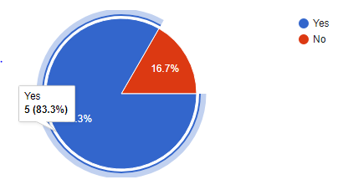

Figure 2 Questionnaire Report

According to the data collected from a random sample of students from the Jomo Kenyatta University of Agriculture and Technology who have interacted with the web based SODeL e-learning system 83% recommended that it to have a mobile application developed.

## **3.5 System Development Methodology**

### **3.5.1 The Unified Process**

The unified process is a use-case-driven, architecture-centric, iterative and incremental development process framework that leverages the Object Management Group's (OMG) UML and is compliant with the OMG's SPEM (Software Process Engineering Meta-model Specification)

The unified process is broadly applicable to different types of software systems, including small-scale and large-scale projects having various degrees of managerial and technical complexity, across different application domains and organizational cultures.

## **3.6 System specification**

System specification describes the features and behavior of a system or software application. It includes a variety of elements that attempts to define the intended functionality required by the customer to satisfy their different users. System specification also defines at a high-level the main business processes that will be supported, what simplifying assumptions have been made and what key performance parameters will need to be met by the system.

**Functional requirements**

The application is expected to do the following.

1. Allow for Authentication of users’.
2. Manage and store users’ information.
3. Display the courses contents

Display information on grades

**Nonfunctional requirement**

The non -functional requirements are as follows:

**Maintainability**

The administrators should have the ease of maintaining the system by, correcting errors, preventing breakdown, perfecting the system and ensuring that it adapts to the changing needs of the user.

**Usability**

The system will be friendly to all users due to simple user interfaces and proper documentation of the system.

## **3.7 System Design**

System design is the process of defining the architecture, components, modules, interfaces and data for a system to satisfy specified requirements. System design therefore is the process of defining and developing systems to satisfy specified requirements of the user.

### **3.7.1. Logical Design**

What a system is doing will change less over time than how it is doing it. This is often conducted via modelling using use case diagrams, class diagrams, Entity- Relationship Diagram to show the flow of activities. In this way, we can furnish an abstraction of the total system through logical design in an orderly explanatory way.

**Data Flow Diagram**

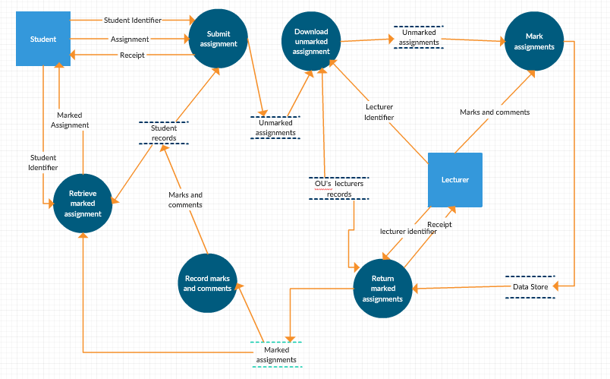

Figure 3 Dataflow Diagram

#### **Use case diagram**

Use case diagrams give a graphic overview of the actors involved in a system together with their different and how these different functions are interacted

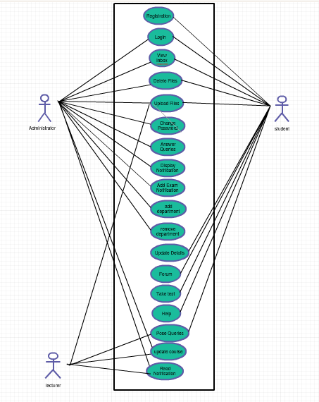

Figure 4 Use case Diagram

**Sequence Diagram**

Sequence diagram, shows how different stakeholders interact with a system by showing activities performed by different stakeholders.

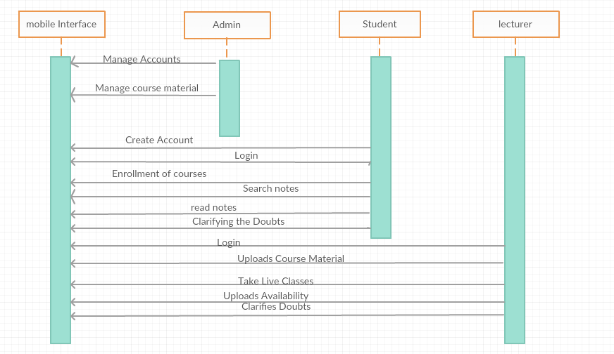

Figure 5 Sequence Diagram

### **3.7.2 Database design**

This is the process of producing a detailed data model of the database. This data model contains all the needed logical and physical design choices and physical storage parameters needed to generate a design in a data definition language which can then be used to create database. This is also carried out in order to reduce redundancy of information.

**Registration details table-**the table holds records of registered users with their respective preferred usernames and passwords. It also has the contacts {phone numbers, and email address} of users.

|  |  |  |  |
| --- | --- | --- | --- |
| **Field** | **Type** | **Null** | **Default** |
| ***ID No*** | int(10) | No |  |
| firstname | varchar(15) | No |  |
| Othername | varchar(15) | No |  |
| PhoneNo | varchar(15) | No |  |
| Email | varchar(50) | No |  |
| gender | varchar(15) | No |  |
| usertype | Varchar(20) | No |  |
| Password | varchar(20) | No |  |

This same table is used by the user to get the username and password for logging in

Courses table

|  |  |  |  |
| --- | --- | --- | --- |
| **Field** | **Type** | **Null** | **Default** |
| course | varchar(25) | No |  |
| school | varchar(15) | No |  |
| coursecode | varchar(40) | No |  |

Assignment table

|  |  |  |  |
| --- | --- | --- | --- |
| **Field** | **Type** | **Null** | **Default** |
| lecturerid | varchar(25) | No |  |
| school | varchar(15) | No |  |
| coursecode | varchar(40) | No |  |

Admin table

|  |  |  |
| --- | --- | --- |
| **Field Name** | **Data type** | **Null** |
| Admin_Id | Int (10) | No |
| Username | Varchar(20) | No |
| Password | Varchar (20) | No |
| Phone | Int(20) | No |

### **3.7.3 Physical Design**

shows the actual input and output of the system

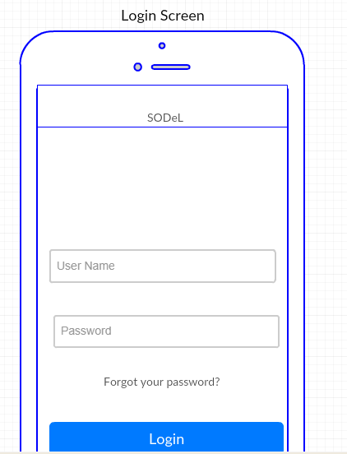

Showing the course units’ page

Figure 6 Physical design 1

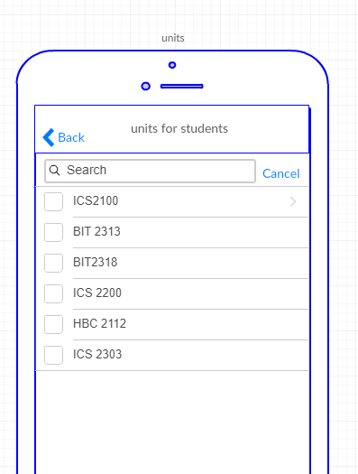

Figure 7 Physical Design 2

# 

# **REFERENCES**

1. Abuhlfaia, K., & Quincey, E. d. (2018). The usability of E-learning platforms in higher education: a systematic mapping study. *HCI '18 Proceedings of the 32nd International BCS Human Computer Interaction Conference* (p. Article No. 7 ). Belfast, United Kingdom : BCS Learning & Development Ltd. Swindon, UK ©2018.
2. Ali, S.I., S. Jain and B. Lal. (2012). A Framework for Modeling and Designing of Intelligent and Adaptive Interfaces for Human Computer Interaction. International Journal of Applied Information Systems (IJAIS)-ISSN: 2249-0868, Foundation of Computer Science FCS, New York, USA, 1(2): 20-25.
3. Al-Harrasi, H., Al-Khanjari, Z., & Sarrab, M. (2015). Proposing a new design approach for m-learning applications*. International Journal of Software Engineering and its Applications, 9(11),* 11-24.
4. Arinto, P. B. (2016). Issues and challenges in open and distance e-learning: Perspectives from the Philippines. The International Review of Research in Open and Distributed Learning, 17(2).
5. Banimahendra, D., & Santoso, H. B. (2018). Implementation and evaluation of LMS mobile application. *Journal of Physics*, 012024.
6. Biel, B., Grill, T. and Gruhn, V. (2010). Exploring the benefits of the combination of a software architecture analysis and a usability evaluation of a mobile application, Journal of Systems and Software (83:11), pp 2031-2044.
7. Chapman, C. (2011). Comprehensive Review of Usability And User Experience Testing Tools. *Smashing Magazine*. Retrieved from: [http://www.smashingmagazine.com/2011/10/comprehens..](http://www.smashingmagazine.com/2011/10/comprehensive-review-usability-user-experience-testing-tools/) Accessed on 4th February 2019
8. Chen, X., Zou, Q., Fan, B., Zheng, Z., & Luo, X. (2018). Recommending software features for mobile applications based on user interface comparison. *Requirements Engineering*, 1-15
9. Giovanis K.,(2015) Keep it simple: Challenges, solutions, and best practices for global eLearning initiatives*,* *International Journal of Advanced Corporate Learning*, 8(2), pp. 47-49,
10. Hadullo, K., Oboko, R., & Omwenga, E. (2018). Factors affecting asynchronous e-learning quality in developing countries. *International Journal of Education and Development using Information and Communication Technology* , Vol. 14, Issue 1, pp. 152-163
11. Harrison, R., Flood, D., & Duce, D. (2013). Usability of mobile applications: literature review and rationale for a new usability model. *Journal of Interaction Science*, *1*(1), 1.
12. Heo, J., H. Dong-Han, P. Sanghyun, S. Chiwon and C.Y. Wan, (2009). A framework for evaluating the usability of mobile phones based on multi-level hierarchical model of usability factors. Interacting Comp., 21(4): 263-275.
13. Jia, W., Hua, Q., Zhang, M., Wang, B., Chen, R., & Ji, X. (2019). Category Theory-Based Mobile User Interface Pattern Recommendation Method. *IEEE Access*, *7*, 8209-8225
14. Jung, N. (2017). Korean learning motivation and demotivation of university students in Singapore. Foreign Languages Education, 24(3), 237-260.
15. Kang, D., & Yoon, K. (2016). A Study on Developing the Interface of Mobile E-learning Application for Children's Foreign Language Education. In *Proceedings of the International Working Conference on Advanced Visual Interfaces* (pp. 320-321). ACM.
16. Kihoro, J., M., &Muya, S., Ibukah, R. (2014). Strategy for Implementation of e-Learning: (lessons from the case of JKUAT and CUCK.
17. Kiruthika, J., Khaddaj, S., Greenhill , D., & Francik, J. (2016). User Experience Design in Web Applications. 2016 *IEEE Intl Conference on Computational Science and Engineering (CSE) and IEEE Intl Conference on Embedded and Ubiquitous Computing (EUC) and 15th Intl Symposium on Distributed Computing and Applications for Business Engineering (DCABES*),642-646.
18. Kisanga, D. (2016). Determinants of Teachers’ Attitudes towards E-Learning in Tanzanian Higher Learning Institutions
19. .Kuo,C., Walker, A.,Belland, B.,Schroder, E.,(2013). A Predictive Study of Student Satisfaction in Online Education Programs.
20. Lim, K., Park, S., & Kang, M. (2016). Structural relationships of environments, individuals, and learning outcomes in Korean online university settings. The International Review of Research in Openand Distributed Learning, 17(4).
21. Makokha, L., & and Mutisya, D., N. (2016). Status of e-Learning in Public Universities in Kenya. Kenyatta University, South Eastern Kenya University
22. Makokha, G., & Mutisya, D. (2016). Status of e-learning in public universities in Kenya. The InternationalReview of Research in Open and Distributed Learning, 17(3).
23. Mayoka, K., & Kyeyune, R. (2012). An analysis of eLearning Information System adoption in Ugandan Universities: Case of Makerere University Business School. Information Technology ResearchJournal, 2(1), 1–7.
24. Muuro, M., Wagacha, W., Kihoro, J., & Oboko, R. (2014). Students’ perceived challenges in an online collaborative learning environment: A case of higher learning institutions in Nairobi, Kenya. TheInternational Review of Research in Open and Distributed Learning, 15(6).
25. Oboko, R., Omwenga, E., & Hadullo, K. (2018). Status of e-Learning Quality in Kenya. *International Review of Research in Open and Distributed Learning*, Volume 19, Number 1.
26. Ojokoh, B. a. (2015). A Mobile-Based E-Learning System. *International Journal of Web-Based Learning and Teaching Technologies*, 1-17
27. Olutola, A. T., & Olatoye, O. O. (2015). Challenges of e-learning technologies in Nigerian University education. Journal of Educational and Social Research, 301-310.
28. P. Kumar, and U. Gulla,(2011) . Corporate e-learning: Possibilities, promises, and realities. *Journal of Library and Information Technology*, 31(3), pp. 179-188, 2011.
29. Remy, C., Bates , O., Dix, A., Thomas , V., Hazas, M., Friday, A., & Huang, E. M. (2018). Evaluation Beyond Usability: Validating Sustainable HCI Research. *Proceedings of the 2018 CHI Conference on Human Factors in Computing Systems* (p. 216). Montreal QC, Canada: ACM New York, NY, USA ©2018.
30. Rouse Margaret. (2019). Mobile UI (mobile user interface) Retrieved from: <https://searchmobilecomputing.techtarget.com/definition/mobile-UI-mobile-user-interface> Accessed on 5th April 2019
31. Saleh, A. M., Fabil, N., & Ismail, R. (2015). Extension of pacmad model for usability evaluation metrics using goal question metrics (Gqm) approach. *Journal of Theoretical and Applied Information Technology* , 79(1)
32. Tarus, J., Gichoya, D., & Muumbo, A. (2015). Challenges of implementing e-learning in Kenya: A case of Kenyan public universities. The International Review of Research in Open and DistributedLearning, 16(1).
33. Wobbrock, J. O., Gajos, K. Z., Kane, S. K., & Vanderheiden, G. C. (2018). Ability-based design. *Communications of the ACM*, *61*(6), 62-71
34. Yang Harrison .( 2013). *New world, New Learning: Trends and issues of E-learning”* Retrieved from: <https://www.sciencedirect.com> Accessed on 5th February 2019

# **1.8 Appendices**

## **1.8.1 Resource Requirement**

The following resources are required for the implementation

### **1.8.1.1 Hardware**

#### **1.8.1.1.1 Laptop**

Laptop with the following specifications

1. Processor core i3
2. 4GB DDR3-1333 RAM
3. 320 GB hard drive
4. Operating system Windows 10 Pro

### **1.8.1.2 Software**

1. Word processors - Microsoft office word for developing the proposal document.
2. Spreadsheet – Microsoft office Excel generating Gantt charts
3. Microsoft office Power Point for presentation purposes
4. Android studio
5. Firebase for application backend

## **1.8.1.3 Other Requirement**

1. Stationery
2. Printing of the proposal document
3. Internet for research purposes

# 

## **1.8.2 Budget and Budget Justification**

|  |  |  |  |  |
| --- | --- | --- | --- | --- |
| **Model number** | **Item definition** | **PRICE PER UNIT** | **NO. OF UNITS** | **TOTAL** **(KSH)** |
|  | laptop | 0 | 1 | 0.00 |
| HUAWEI E5573Cs-322 | modem | 5,400 | 1 | 5,400.00 |
|  | Word processor | 0 |  | 0.00 |
|  | Ms project | 0 |  | 0.00 |
|  | stationery | 200 |  | 200.00 |
|  | printing | 500 |  | 500.00 |
|  | Internet | 1,000 |  | 1,000.00 |
|  |  |  |  | 7,100.00 |

Table 1: BUDGET AND BUDGET JUSTIFICATION

## 

|  |  |  |  |  |  |  |  |
| --- | --- | --- | --- | --- | --- | --- | --- |
|  | **Description** | **Duration**  **(Weeks)** | **Proposed Start date** | **Proposed Finish date** | **Actual Start Date** | **Actual Finish Date** | **Deliverables** |
| 1 | Project Identification | 1 | 14/1/19 | 18/1/19 | 21/1/19 | 25/1/19 | Research project  idea |
| 2 | Draft Proposal  Writing | 1 | 28/1/19 | 1/2/19 | 29/1/19 | 1/3/19 | Draft Proposal |
| 3 | Final Proposal | 1 | 4/2/19 | 6/2/19 | 14/2/19 | 22/2/19 | Final Proposal |
| 4 | Literature Review | 1 | 11/2/19 | 15/2/19 | 15/3/19 | 23/3/19 | Literature review report |
| 5 | Data collection  And analyses | 2 | 6/5/19 | 17/5/19 |  |  | Requirements specification |
| 7 | System design | 3 | 20/5/19 | 7/6/19 |  |  | System design |
| 8 | System Development | 3 | 10/6/19 | 28/6/19 |  |  | Working System |
| 9 | Testing | 1 | 1/7/19 | 5/7/19 |  |  | Working System |
| 10 | Project Report | 1 | 8/7/19 | 12/7/19 |  |  | Project Report |

## **1.8.3 Project Time Plan**

# **Gantt chart**

**Sample Questionnaire**

I am James Njoroge Njuguna from Jomo Kenyatta University of Agriculture and Technology. If it is not too much trouble take a couple of minutes to express your conclusions on the underneath inquiries. Your answers are essential to the accomplishment of this examination. Please answer with 'YES or NO' where required. This is the poll is aimed at getting opinion on development of a mobile based interface for e-learning

1. What’s your gender? Male [ ] Female [ ]
2. Are you a student? YES [ ] NO [ ]
3. If yes, which mode of study do you use?

Full-Time/Regular Day [ ]

Evening [ ]

Weekend /Part-Time [ ]

Distance Learning [ ]

1. Are you a Jomo Kenyatta University of Agriculture and Technology student?

YES [ ] NO [ ]

1. Have you used the SODeL e-Learning system?

YES [ ] NO [ ]

1. Challenges faced when using the web based e-learning system?

|  |
| --- |
|  |
|  |

1. Do you find the system effective? YES [ ] NO [ ] NOT SURE [ ]

If NO, what recommendations would you give?

|  |
| --- |
|  |
|  |

1. would you recommend a mobile application for SODeL?

YES [ ] NO [ ] NOT SURE [ ]

Thank you for agreeing to take part in this survey. All of the answers you provide in this survey will be kept confidential. No identifying information will be provided to the public. The survey data will be reported in a summary fashion only and will not identify any individual person.